Application Form for participation in Webinars:
Dissemination of the Knowledge on Application of Ionising Radiation for Sterilization of Medical Equipment, Personal Protection Equipment and the other Microbiologically Infected Objects
Oct.07th 2020 at 2 pm
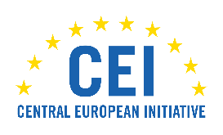

 |  | Please select
Title |  | Mr., Mrs., Dr., Prof.
First name
Family name
Institution
Institution type |  | Academia, Institute, Industry, Hospital, Other
Professional activity/position |  | Student, Teacher, Doctor, Researcher, Health Operator, Entrepreneur, Other
Country
Address*
e-mail

*optional

Please send the filled Application Form to: radiation.sterilization@ichtj.waw.pl

